Week-6 ASSIGNMENT
SETUP PYSPARK

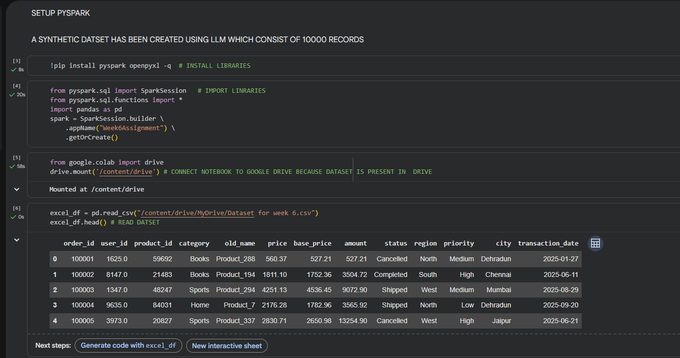
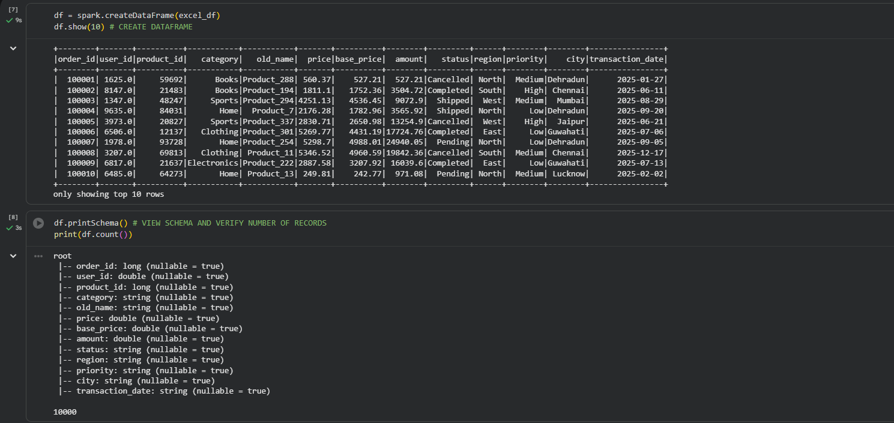

DATASET USED
Created A synthetic Retail sales dataset consisting of 10,000 Records Using LLM . It is created to simulate Real world Data. The Dataset designed contains Impurities In order to perform Cleaning operations.

Q1: Explain the roles of the Driver, Cluster Manager, and Executor in a Spark application.
ANSWER:
Driver: The main program that creates the SparkSession, coordinates tasks, and collects results.
Cluster Manager: Allocates resources (CPU and memory) across the cluster forSpark applications.
Executors: Worker processes that execute tasks, store data in memory, and return results to the Driver.
Q2: How does Spark’s Lazy Evaluation strategy improve performance when chain-processing large datasets?
THEORY:
Spark does not execute transformations immediately. Instead, it records them in a DAG (Directed Acyclic Graph) and executes them only when an action is called. This allows Spark to optimize the execution plan, reduce unnecessary computations, and minimize disk I/O, improving performance.
CODE: 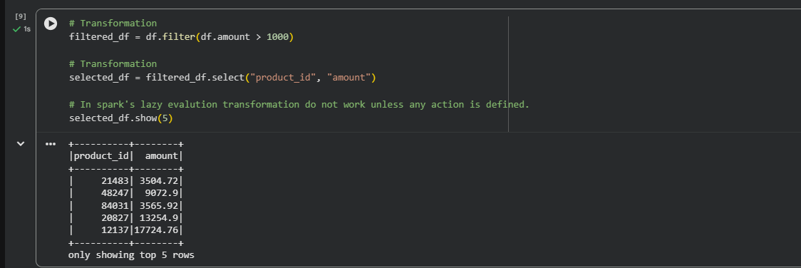

Q3: Write a Spark command to read a CSV file located at "data/source.csv", ensuring the first row is treated as a header and inferSchema is enabled.
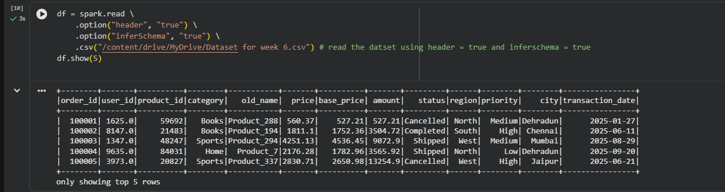

Q4: What is the difference between CSV and Parquet in terms of storage (row-based vs. columnar) and why does it matter for performance?
THEORY:
Theory Answer
CSV | Parquet
Row-based storage | Columnar storage
Larger file size | Smaller due to compression
Slower query performance | Faster query performance
No built-in schema | Stores schema information
Best for data exchange | Best for analytics and big data
Parque is gernally preferred over csv because:
CSV stores data row by row. If you need only one column, Spark still reads every column in each row.
Parquet stores data column by column. Spark reads only the required columns, reducing disk I/O and improving performance.
Parquet also supports compression and Predicate Pushdown, making it ideal for big data processing.

CODE : 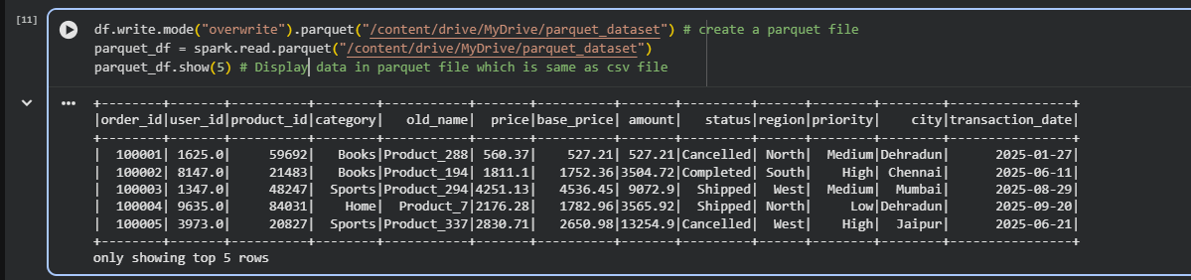

Q5: Given a DataFrame df, write a query to select the columns product_id and price where the category is 'Electronics'.
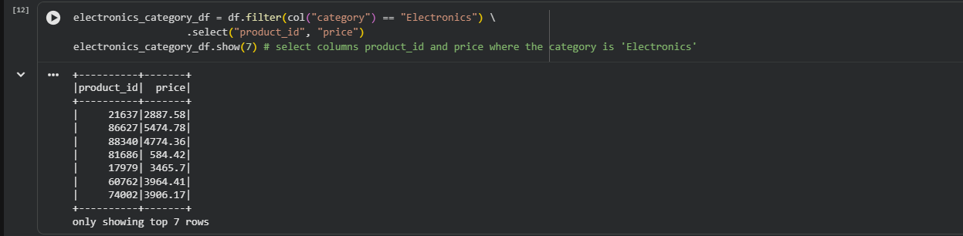

Q6: Write the code to "revise" a DataFrame by renaming the column old_name to new_name and casting the price column from a String to a Double.
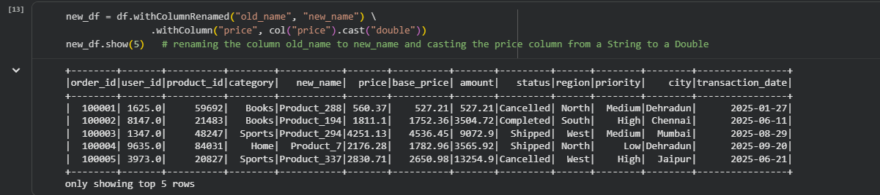

Q7: How does Spark use the Lineage Graph (DAG) to provide fault tolerance if a worker node fails?
ANSWER:
Apache Spark maintains a Lineage Graph, also known as a Directed Acyclic Graph (DAG), which records all the transformations (such as filter(), select(), and groupBy()) performed on a dataset.
When a worker node fails, some data partitions may be lost. Instead of restarting the entire job or restoring data from backups, Spark uses the Lineage Graph to determine how the lost partitions were created and recomputes only those lost partitions from the original data.
Q8: Write a query to filter a DataFrame df_orders for rows where the status is 'Completed' AND the amount is greater than 1000.
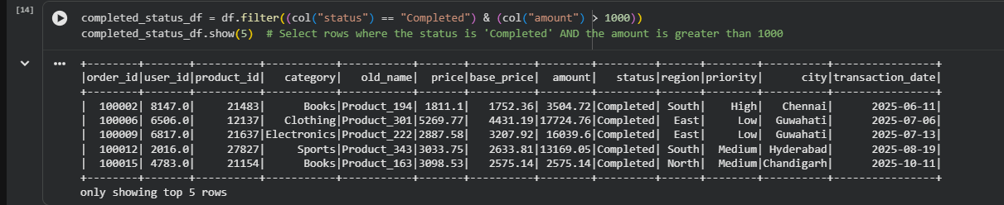
Q9: Explain the concept of Predicate Pushdown in Parquet and how it affects the amount of data loaded into memory.
ANSWER :
Predicate Pushdown is an optimization technique used by Spark when reading Parquet files. Instead of loading the entire dataset into memory and then applying filters, Spark pushes the filter condition down to the Parquet file reader.
Which results rows that satisfy the filter condition are read into memory, while the remaining rows are skipped.
This helps to reduce Disk I/O and Memory usage and CPU processing time and also improves query performance, especially for large datasets.

Q10: Write a code snippet to add a new column final_price which is the base_price multiplied by 1.18 (18% tax).
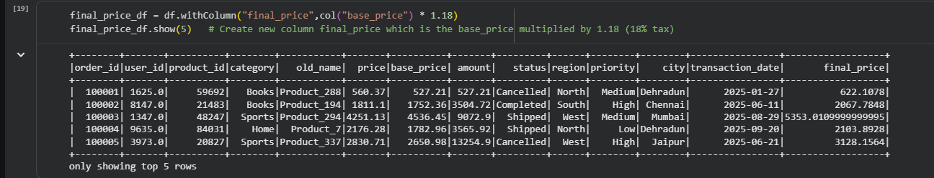
Q11: What is the difference between Transformations and Actions? Provide two examples of each.
ANSWER:
Transformations
- Transformations create a new DataFrame or RDD from* an existing one.
- They are lazy, meaning Spark does not execute them immediately. Instead, Spark builds a DAG (Directed Acyclic Graph) and waits until an action is called.
Examples
Select()
Filter()

Q12: Write the Spark command to load a Parquet file from "path/to/input", filter out any rows where user_id is null, and save the result as a CSV at "path/to/output".

Q13: In Spark Architecture, what is the difference between Client Mode and Cluster Mode?
ANSWER:
Client Mode
- The Driver runs on the local machine
- Executors run on the cluster's worker nodes.
- The client machine must remain connected until the job finishes.
Use Case: Suitable for development, testing, and debugging.
Cluster Mode
- The Driver runs inside the cluster on one of the worker nodes.
- Executors also run on the cluster.
- The client can disconnect after submitting the job because the cluster manages the execution.
Use Case: Preferred for production environments and long-running jobs.

Q14: Write a query to filter a dataset for rows where the region is 'North' OR the priority is 'High'.
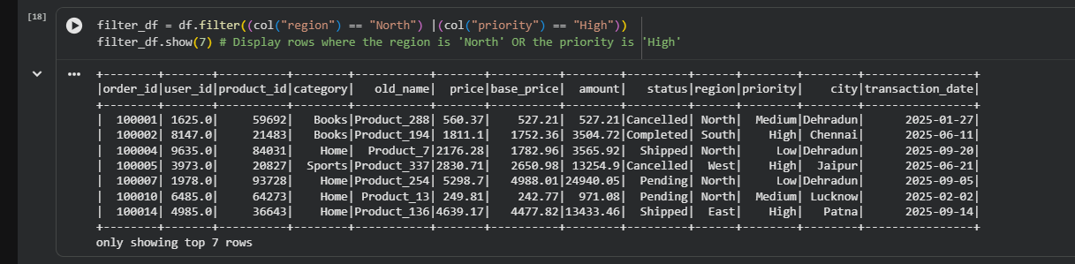

Q15: When exploring a dataset, why is it safer to use .show(5) instead of .collect() on a multi-terabyte dataset?
ANSWER:
When working with a multi-terabyte dataset, it is much safer to use .show(5) because it displays only the first 5 rows of the DataFrame.
while .collect() retrieves all the rows from the distributed cluster and brings them into the Driver's memory. For very large datasets, this can consume a huge amount of memory, leading to OutOfMemory (OOM) errors or even causing the Spark application to crash.

-

